**Presentation Layer:**

* Create a Subject Area
* Create Presentation Tables
* Create Presentation Columns
* Rename Presentation Columns
* Reorder Presentation Columns

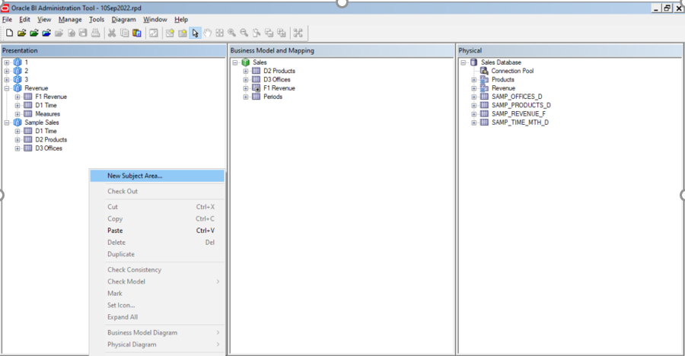

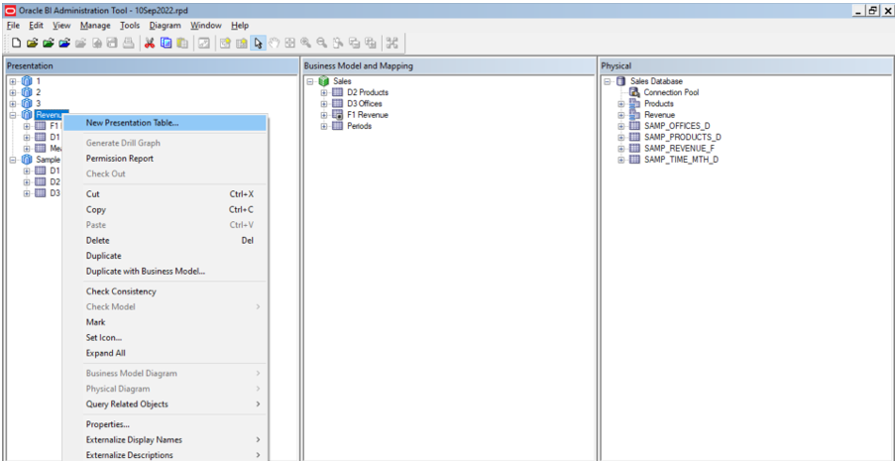

* One business model we can develop ‘n’ number of subject areas
* Contains columns from one or more logical tables.
* Modify independently of logical tables

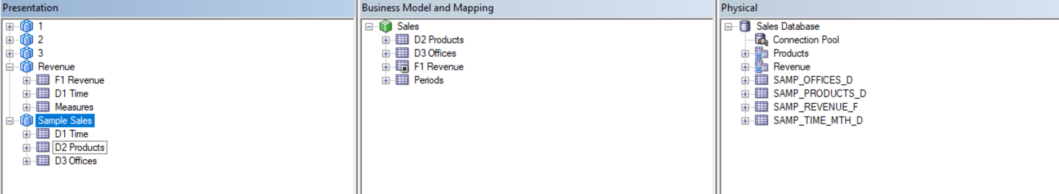

**Steps:**

1. Created a new subject area

2. Creating presentation tables and columns

3. Rename tables

4. Reorder tables

5. Delete columns

6. Rename columns

7. Reorder columns

8. Nested presentation tables

Permissions:

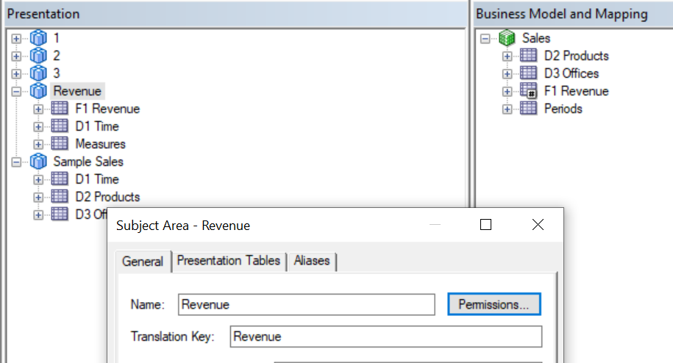

References:

Please review the below steps in the URL for more detail about presentation layer

<https://docs.oracle.com/middleware/1221/biee/BIEMG/presentationlayer.htm#BIEMG266>